Compare 2 digit numbers

DESCRIPTION:
You are given 2 two-digit numbers. You should check if they are similar by comparing their numbers, and return the result in %.
Example:
- compare(13,14)=50%;
- compare(23,22)=50%;
- compare(15,51)=100%;
- compare(12,34)=0%.

SOLUTION:
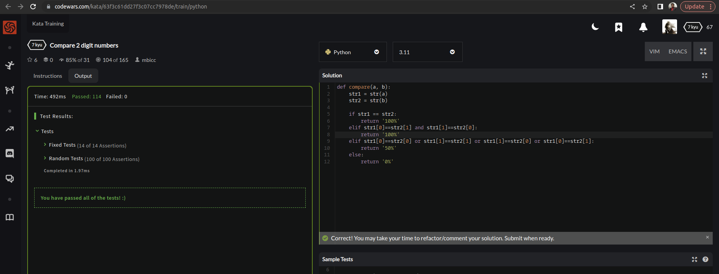

EXPLANATION:
This is a Python function named compare that finds comparison between 2 arguments a and b. It converts both arguments to strings and then compares them to determine their similarity. If the two strings are equal, the function returns '100%'. Otherwise, if the first character of a matches the second character of b and the second character of a matches the first character of b, the function also returns '100%'. If neither of the above conditions are met, the function checks if any of the individual characters of a match the individual characters of b. If any of these characters match, the function returns '50%'. If none of the characters match, the function returns '0%'. It's worth noting that the function assumes that a and b are both strings or can be converted to strings.

